DW系列凸轮式闪光对焊机
DW Series Cam Type Butt-Flash Welding Machine
DW系列凸轮式闪光对焊机

该新型闪光对焊机由美国焊接技术协会和德力焊接设备有限公司共同努力开发而成，融合了最新的焊接科学技术，使用了最优良的元器件。
一流品牌的电机保证了对焊接步调和侧向顶锻的精确控制，比传统的液压方式更优良，欧洲技术的控制系统保证了对各个焊接步骤和焊接参数精确操作，包括高难度退火。
精密型导轨保证了工件的完美对接，从而最大限度的减少了焊接后工具的再加工。在
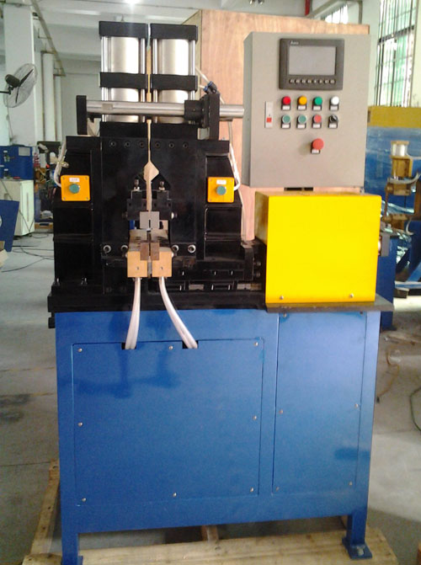

美国专家的指导下，德力焊接有限公司完全具备了加工和制造世界一流机器的能力。
焊接不同工件时，调节起来特别方便，只需几分钟。
水冷变压器，可控硅和夹具等确保了机器的长时间高负荷工作。
这种通用型闪光对焊机，是焊接各种小批量，多规格，多品种材料产品的理想选择。
技术参数

DW-100KVA闪光对焊机，适合焊接直径不大于30mm的低碳
钢，或者直径不大于20mm的铜棒。
DW-200KVA闪光对焊机，适合焊接直径不大于45mm的低碳
钢，或者直径不大于30mm的铜棒。
冷却水流量：12L/Min;
气源压力：0.6Mpa;
夹紧力：6,000kgf；
顶锻力：3,000kgf.
DW Series Cam Type Butt-Flash Welding Machine
New universal butt-flash welding machine has been successfully developed efforts of welding Technologies USA and Guangzhou DuroWelder Ltd.
This unique machine combines latest developments in welding science and the best quality components found around the world.Electromechanical drive made in USA allows super precision control of speed and upset force, exceeding even hydraulic type drives for its material range.
Welding control made by European manufacturer allows versatile weld parameters to be implemented, including annealing process when required.
Precision rails guarantee perfect alignment in between welded pieces therefore minimizing possible waste when weldments are machined.
Guang Zhou DuroWelder technicians, trained by the experts from parent Company Welding
Technologies, demonstrate world-class craftsmanship in manufacturing process and assembly of the machine.
Butt-Flash welder can be adjusted from one type of product (e.g.30mm dia steel rods) to another (16mm dia copper squares) within minutes.
Water cooled transformer available as 100KVA option along with water cooled SCR and Jaws provide comfortable conditions for heavy duty application when high rate of production is required.
This universal butt-flash welder can be ideal in situations when manufacturer has to produce small batches of weldments made of various sizes and material.
100KVA option welds 30mm dia mild steel, or 20mm dia copper rod.
200KVA option increases range of welded parts by 40%.
Water cooling flow: 12L/Min.
Air Pressure: 0.6Mpa.
Clamping Force: 6,000kgf.
Upset force: 3,000kgf.
Main Parameters
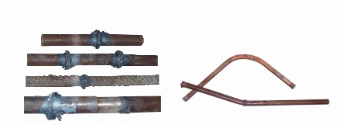

焊接样品 Welding Sample

