DN系列气动交流点（凸）焊机
DN Series Pneumatic AC Spot & Projection Welding Machine

整机特点：
- 全数字式微电脑控制系统，可预热、焊接、回火三段位放电，配备恒压、恒流、恒热量、缓升、缓降、储存多组焊接规范等功能，轻松满足客户对焊接产品品质的高要求；
- 一体式高强度机架结构，高气压操作时，更具有抗冲击及抗震能力，实现焊接位置更精确，点焊和凸焊兼用，最大发挥焊接性能；
- 全铜水冷变压器，进口硅钢片，环氧树脂浇铸，占载率高，使用寿命更长；
4、多路强制水冷却系统可确保机器长期运行的可靠性；
5、按照国际ISO标准化进行生产，并且通过欧洲CE认证。

Main Features
- Full digital microcomputer control system,three grades discharge design (Pre-pressing,welding and tempering),equipping functions of Constant Voltage,Constant Current,Constant Heating,Slowly Increasing,Slowly Decreasing,save multi-group Schedule Number,etc.easily meet customers’ high requirements of welding quality;
- Integrated high-strength frame Structure,more impact resistant and anti-shock ability under high pressure operation,to achieve more accuracy of welding position,both spot welding and projection welding,reach the largest welding performance;
- All copper water-cooling transformer,Multi-channel forced water cooling system to ensure the reliability of the machine running for long time;
- Manufactured in accordance with international ISO Standard and European CE Certificate.

主要技术参数 Main Technical Parameters

项目  Item | 额定容量 | 额定初级电压 | 额定  频率 | 最大次极电流 | 负载持续率 | 臂伸尺寸 | 最大加压力 | 电极  行程 | 冷却水  流量 | 重量 | 电极尺寸  Electrode size
型号  Model | Rated  capacity | Rated  Primary  voltage | Rated  frequency | Max.  Secondary  Current | Rated  duty cycle | Arm  length | Maximum  Force | Electrode  stroke | Cooling  Water flow | Weight | 电极头  Electrode  Head | 电极握杆  Electrode holding rod | 电极臂杆  Electrode arm
型号  Model | KVA | V | Hz | A | % | mm | N | mm | L/min | Kg | (mm) | (mm) | (mm)
DN-25 | 25 | 380 | 50/60 | 17500 | 50 | 380 | 2500 | 60 | 6 | 300 | 16 | 20 | 45*200
DN-35 | 35 | 380 | 50/60 | 18500 | 50 | 380 | 4000 | 60 | 6 | 380 | 16 | 25 | 50*200
DN-50 | 50 | 380 | 50/60 | 20000 | 50 | 380 | 4000 | 60 | 6 | 430 | 16 | 25 | 50*200
DN-75 | 75 | 380 | 50/60 | 25000 | 50 | 380 | 6280 | 60 | 8 | 500 | 16 | 25 | 60*200
DN-100 | 100 | 380 | 50/60 | 30500 | 50 | 380 | 6280 | 60 | 8 | 600 | 16 | 25 | 60*200
DN-150 | 150 | 380 | 50/60 | 38500 | 50 | 380 | 9800 | 60 | 12 | 750 | 20 | 30 | 80*250
DN-200 | 200 | 380 | 50/60 | 43000 | 50 | 380 | 9800 | 60 | 12 | 800 | 20 | 30 | 80*250

机器照片 Machine Pictures
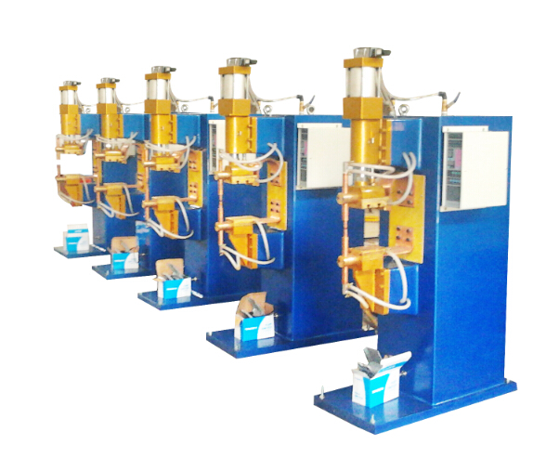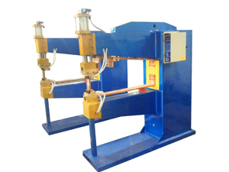
焊接样品：Welding Samples
1.板材焊接样品 Sheet Welding Samples
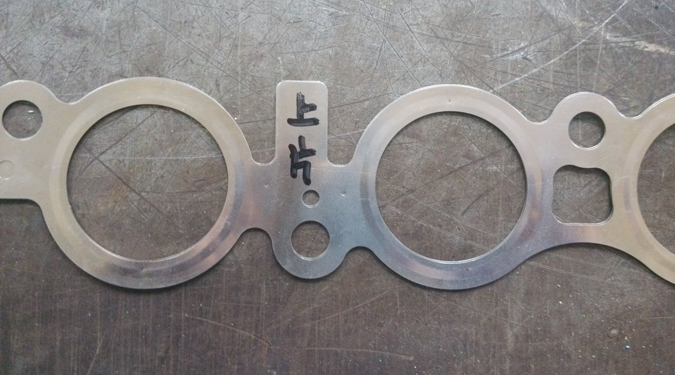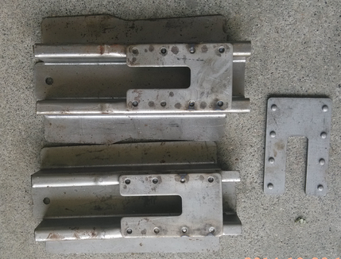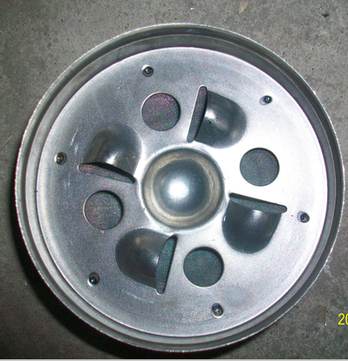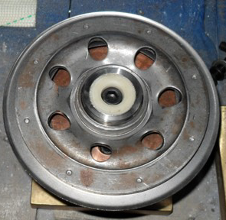
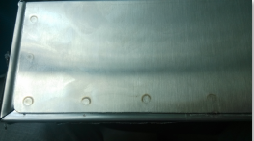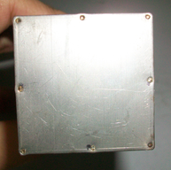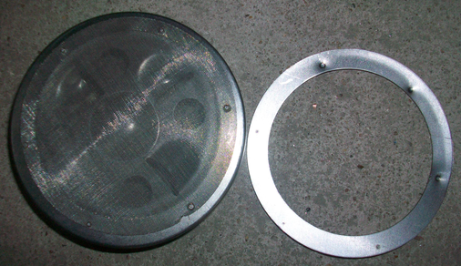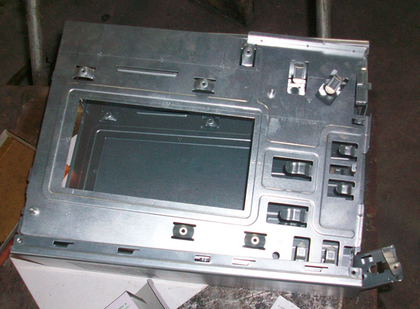

3.螺母焊接样品
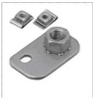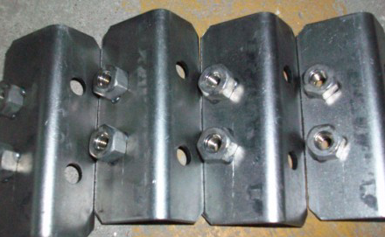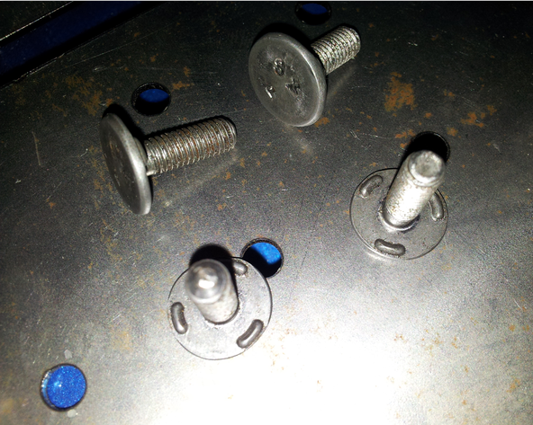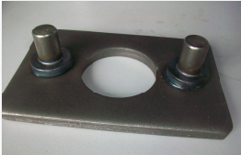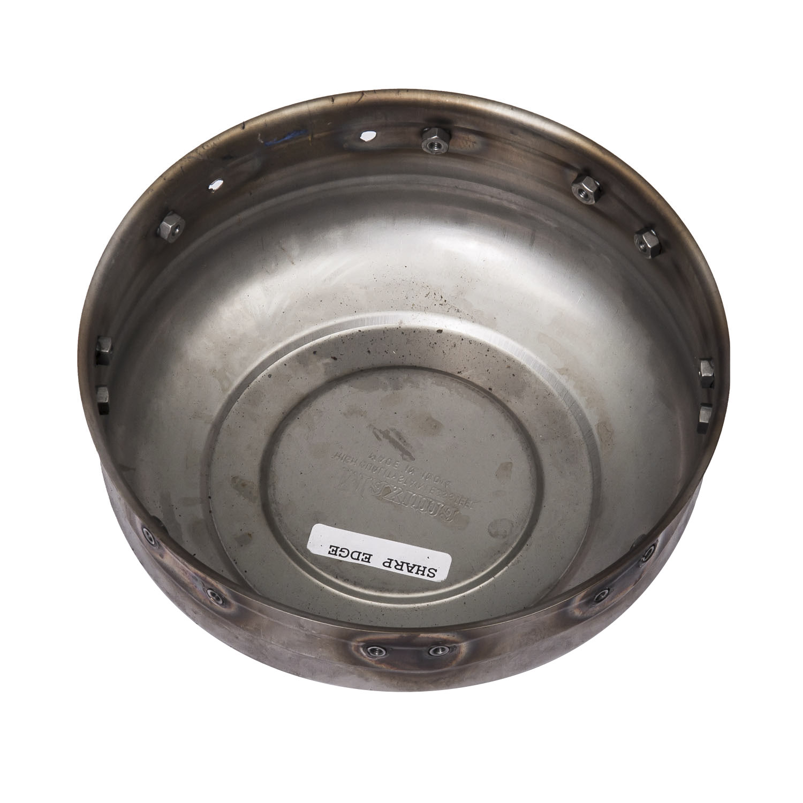

- 线材焊接样品 Wires Welding Samples
