Y2系列外形尺寸图（IMB3）
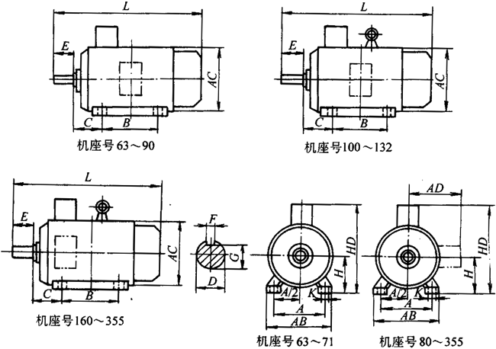
机座带底脚，端盖上无凸缘的电动机（IMB3） （单位：mm）
机座号 | 极数 | A | B | C | D | E | F | G | H | K | AB | AC | AD | HD | L
 | 4、6、8、10 |  |  |  | 80 | 170 | 22 | 71 |  |  |  |  |  |  | 1270
315M | 2 |  | 457 |  | 65 | 140 | 18 | 58 |  |  |  |  |  |  | 1190
315M | 4、6、8、10 |  | 457 |  | 80 | 170 | 22 | 71 |  |  |  |  |  |  | 1300
315L | 2 |  | 508 |  | 65 | 140 | 18 | 58 |  |  |  |  |  |  | 1190
315L | 4、6、8、10 |  | 508 |  | 80 | 170 | 22 | 71 |  |  |  |  |  |  | 1300
355M | 2 | 610 | 560 | 254 | 75 | 140 | 20 | 67.5 | 355 |  | 730 | 710 | 655 | 1010 | 1500
355M | 4、6、8、10 | 610 | 560 | 254 | 95 | 170 | 25 | 86 |  |  |  |  |  |  | 1530
355L | 2 | 610 | 630 | 254 | 75 | 140 | 20 | 67.5 |  |  |  |  |  |  | 1500
355L | 4、6、8、10 | 610 | 630 | 254 | 95 | 170 | 25 | 86 |  |  |  |  |  |  | 1530

Y2系列外形尺寸图（IMB35）
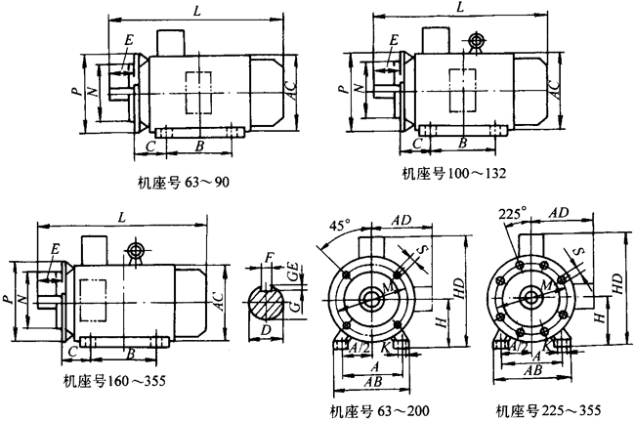

机座还底脚，端盖上有凸缘（带通孔）的电动机（IMB35） （单位：mm）
机座号 | 凸缘号 | 极 数 | A | B | C | D | E | F | G | H | K | M | N | P | S | AB | AC | AD | HD | L
63 | FF115 | 2、4 | 100 | 80 | 40 | 11 | 23 | 4 | 8.5 | 63 | 7 | 115 | 95 | 140 | 10 | 135 | 130 | 70 | 180 | 230
71 | FF130 | 2、4、6 | 112 | 90 | 45 | 14 | 30 | 5 | 11 | 71 | 7 | 130 | 110 | 160 | 10 | 150 | 145 | 80 | 195 | 255
80 | FF165 | 2、4、6、8 | 125 | 100 | 50 | 19 | 40 | 6 | 15.5 | 80 | 10 | 165 | 130 | 200 | 12 | 165 | 175 | 145 | 214 | 295
90S | FF165 | 2、4、6、8 | 140 | 100 | 56 | 24 | 50 | 8 | 20 | 90 |  |  |  |  |  | 180 | 195 | 155 | 250 | 315
90L | FF165 | 2、4、6、8 | 140 | 125 |  |  |  |  |  |  |  |  |  |  |  |  |  |  |  | 340
100L | FF215 | 2、4、6、8 | 160 | 140 | 63 | 28 | 60 | 8 | 24 | 100 | 12 | 215 | 215 | 250 | 15 | 205 | 215 | 180 | 270 | 335
112M | FF215 | 2、4、6、8 | 190 | 140 | 70 |  |  |  |  | 112 |  |  |  |  |  | 230 | 240 | 190 | 300 | 400
132S | FF265 | 2、4、6、8 | 216 | 140 | 89 | 38 | 80 | 10 | 33 | 132 | 12 | 265 | 265 | 300 | 15 | 270 | 275 | 210 | 345 | 470
132M | FF265 | 2、4、6、8 | 216 | 178 |  |  |  |  |  |  |  |  |  |  |  |  |  |  |  | 510
160M | FF300 | 2、4、6、8 | 254 | 210 | 108 | 42 | 110 | 12 | 37 | 160 | 15 | 300 | 15 | 350 | 19 | 320 | 330 | 255 | 420 | 615
160L | FF300 | 2、4、6、8 | 254 | 254 |  |  |  |  |  |  |  |  |  |  |  |  |  |  |  | 670
180M | FF300 | 2、4、6、8 | 279 | 241 | 121 | 48 | 110 | 14 | 42.5 | 180 |  |  |  |  |  | 355 | 380 | 280 | 455 | 700
180L | FF300 | 2、4、6、8 | 279 | 279 |  |  |  |  |  |  |  |  |  |  |  |  |  |  |  | 740
200L | FF300 | 2、4、6、8 | 318 | 305 | 133 | 55 | 110 | 16 | 49 | 200 | 19 | 300 | 19 | 400 | 19 | 395 | 420 | 305 | 505 | 770
续
225S | FF400 | 4、8 | 356 | 286 | 149 | 60 | 140 | 18 | 53 | 225 | 19 | 400 | 350 | 450 | 19 | 435 | 470 | 335 | 555 | 820
225M | FF400 | 2 | 356 | 311 | 149 | 55 | 110 | 16 | 49 |  |  |  |  |  |  |  |  |  |  | 815
225M | FF400 | 4、6、8 | 356 | 311 | 149 | 60 | 140 | 18 | 53 |  |  |  |  |  |  |  |  |  |  | 845
250M | FF500 | 2 | 406 | 349 | 168 |  |  |  |  | 250 | 24 | 500 | 450 | 550 | 19 | 490 | 510 | 370 | 615 | 910
250M | FF500 | 4、6、8 | 406 | 349 | 168 | 65 | 140 | 18 | 58
280S | FF500 | 2 | 457 | 368 | 190 |  |  |  |  | 280 |  |  |  |  |  | 550 | 580 | 410 | 680 | 985
280S | FF500 | 4、6、8 | 457 | 368 | 190 | 75 | 140 | 20 | 67.5
280M | FF500 | 2 | 457 | 419 | 190 | 65 | 140 | 18 | 58 |  |  |  |  |  |  |  |  |  |  | 1035
280M | FF500 | 4、6、8 | 457 | 419 | 190 | 75 | 140 | 20 | 67.5
315S | FF600 | 2 | 508 | 406 | 216 | 65 | 140 | 18 | 58 | 315 | 28 | 600 | 550 | 660 | 24 | 635 | 645 | 530 | 845 | 1160
315S | FF600 | 4、6、8、10 | 508 | 406 | 216 | 80 | 170 | 22 | 71 |  |  |  |  |  |  |  |  |  |  | 1270
315M | FF600 | 2 | 508 | 457 | 216 | 65 | 140 | 18 | 58 |  |  |  |  |  |  |  |  |  |  | 1190
315M | FF600 | 4、6、8、10 | 508 | 457 | 216 | 80 | 170 | 22 | 71 |  |  |  |  |  |  |  |  |  |  | 1300
315L | FF600 | 2 | 508 | 508 | 216 | 65 | 140 | 18 | 58 |  |  |  |  |  |  |  |  |  |  | 1190
315L | FF600 | 4、6、8、10 | 508 | 508 | 216 | 80 | 170 | 22 | 71 |  |  |  |  |  |  |  |  |  |  | 1300
355M | FF740 | 2 | 254 | 560 | 254 | 75 | 140 | 20 | 67.5 | 355 | 28 | 740 | 680 | 800 | 24 | 730 | 710 | 650 | 1010 | 1500
355M | FF740 | 4、6、8、10 | 254 | 560 | 254 | 95 | 170 | 25 | 86 |  |  |  |  |  |  |  |  |  |  | 1530
355L | FF740 | 2 | 254 | 630 | 254 | 75 | 140 | 20 | 37.5 |  |  |  |  |  |  |  |  |  |  | 1500
355L | FF740 | 4、6、8、10 | 254 | 630 | 254 | 95 | 170 | 25 | 86 |  |  |  |  |  |  |  |  |  |  | 1330
Y2系列外形尺寸图（B5）
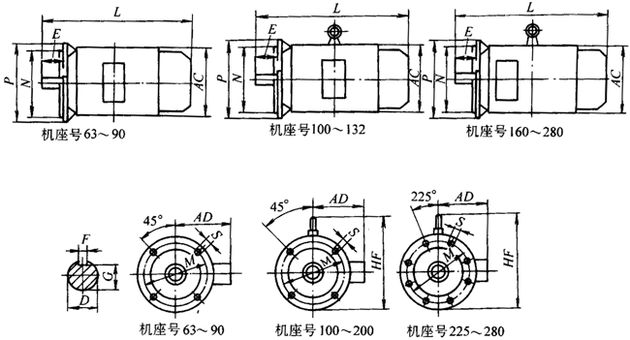

机座不带底脚，端盖上有凸缘（带通孔）的电动机（IMB5） （单位：mm）
机座号 | 凸缘号 | 极 数 | D | E | F | G | M | N | P | S | AC | AD | HF | L
63 | FF115 | 2、4 | 11 | 23 | 4 | 8.5 | 115 | 95 | 140 | 10 | 130 | 70 | 130 | 230
71 | FF130 | 2、4、6 | 14 | 30 | 5 | 11 | 130 | 110 | 160 | 10 | 145 | 80 | 145 | 255
80 | FF165 | 2、4、6、8 | 19 | 40 | 6 | 15.5 | 165 | 130 | 200 | 12 | 175 | 145 | 185 | 295
90S | FF165 | 2、4、6、8 | 24 | 50 | 8 | 20 |  |  |  |  | 195 | 155 | 195 | 315
90L |  |  |  |  |  |  |  |  |  |  |  |  |  | 340
100L | FF215 | 2、4、6、8 | 28 | 60 | 8 | 24 | 215 | 180 | 250 | 15 | 215 | 180 | 245 | 385
112M |  |  |  |  |  |  |  |  |  |  | 240 | 190 | 265 | 400
132S | FF265 | 2、4、6、8 | 38 | 80 | 10 | 33 | 265 | 230 | 300 | 15 | 275 | 210 | 315 | 470
132M |  |  |  |  |  |  |  |  |  |  |  |  |  | 510
160M | FF300 | 2、4、6、8 | 42 | 110 | 12 | 37 | 300 | 250 | 350 | 19 | 330 | 255 | 385 | 615
160L |  |  |  |  |  |  |  |  |  |  |  |  |  | 670
180M | FF300 | 2、4、6、8 | 48 | 110 | 14 | 42.5 |  |  |  |  | 380 | 280 | 430 | 700
180L |  |  |  |  |  |  |  |  |  |  |  |  |  | 740
200L | FF350 | 2、4、6、8 | 55 | 110 | 16 | 49 | 350 | 300 | 400 | 19 | 420 | 305 | 480 | 770
225S | FF400 | 4、8 | 60 | 140 | 18 | 53 | 400 | 350 | 450 | 19 | 470 | 335 | 535 | 820
225M | FF400 | 2 | 55 | 110 | 16 | 49 |  |  |  |  |  |  |  | 815
225M | FF400 | 4、6、8 | 60 | 140 | 18 | 53 |  |  |  |  |  |  |  | 845
250M | FF500 | 2 |  |  |  |  | 500 | 450 | 550 | 19 | 510 | 370 | 595 | 910
250M | FF500 | 4、6、8 | 65 | 140 | 18 | 58
280S | FF500 | 2 |  |  |  |  |  |  |  |  | 580 | 410 | 650 | 985
280S | FF500 | 4、6、8 | 75 | 140 | 20 | 67.5
280M | FF500 | 2 | 65 | 140 | 18 | 58 |  |  |  |  |  |  |  | 1035
280M | FF500 | 4、6、8 | 75 | 140 | 20 | 67.5
Y2系列外形尺寸图（IMB34）
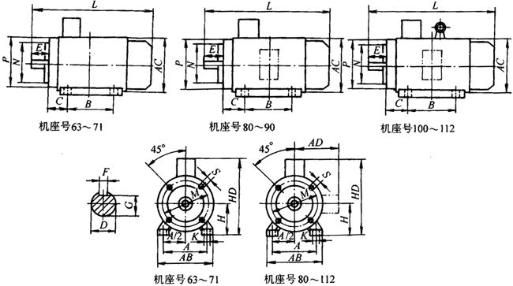
机座带底脚，端盖上有凸缘（带螺孔）的电动机（IMV34） （单位：mm）
机座号 | 凸缘号 | 极 数 | A | B | C | D | E | F | G | H | K | M | N | P | S | AB | AC | AD | HD | L
63 | FT75 | 2、4 | 110 | 80 | 40 | 11 | 23 | 4 | 8.5 | 63 | 7 | 75 | 60 | 90 | M5 | 135 | 130 | 70 | 180 | 230
71 | FT85 | 2、4、6 | 112 | 90 | 45 | 14 | 30 | 5 | 11 | 71 | 7 | 85 | 70 | 105 | M6 | 150 | 145 | 80 | 195 | 255
80 | FT100 | 2、4、6、8 | 125 | 100 | 50 | 19 | 40 | 6 | 15.5 | 80 | 10 | 100 | 80 | 120 | M6 | 165 | 175 | 145 | 214 | 295
90S | FT115 | 2、4、6、8 | 140 | 100 | 56 | 24 | 56 | 8 | 20 | 90 | 10 | 115 | 95 | 140 | M8 | 180 | 195 | 155 | 250 | 315
90L | FT115 | 2、4、6、8 | 140 | 125 |  |  |  |  |  |  |  |  |  |  |  |  |  |  |  | 340
100L | FT130 | 2、4、6、8 | 160 | 140 | 60 | 28 | 60 | 8 | 24 | 100 | 12 | 130 | 110 | 160 | M8 | 205 | 215 | 180 | 270 | 385
112M | FT130 | 2、4、6、8 | 190 | 140 |  |  |  |  |  | 112 |  |  |  |  |  | 230 | 240 | 190 | 300 | 400
Y2系列外形尺寸图（IMB14）
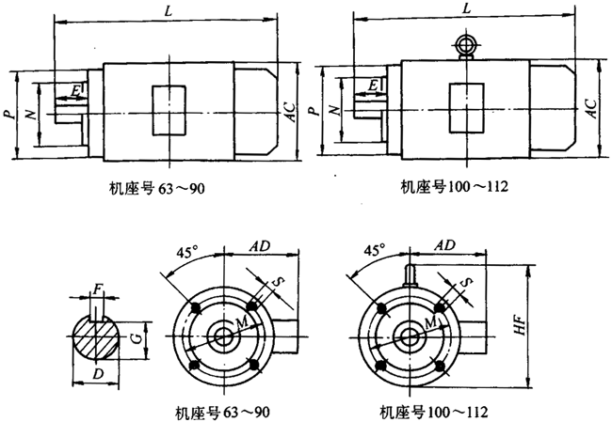
机座不带底脚，端盖上有凸缘（带螺孔）的电动机（IMB14） （单位：mm）
机座号 | 凸缘号 | 极 数 | D | E | F | G | M | N | P | S | AC | AD | HF | L
63 | FT75 | 2、4 | 11 | 23 | 4 | 8.5 | 75 | 60 | 90 | M5 | 130 | 70 | 130 | 230
71 | FT85 | 2、4、6 | 14 | 30 | 5 | 11 | 85 | 70 | 105 | M6 | 145 | 80 | 145 | 255
80 | FT100 | 2、4、6、8 | 19 | 40 | 6 | 15.5 | 100 | 80 | 120 | M6 | 175 | 145 | 185 | 295
90S | FT115 | 2、4、6、8 | 24 | 50 | 8 | 20 | 115 | 95 | 140 | M8 | 195 | 155 | 195 | 315
90L |  |  |  |  |  |  |  |  |  |  |  |  |  | 340
100L | FT130 | 2、4、6、8 | 28 | 60 | 8 | 24 | 130 | 110 | 160 | M8 | 215 | 180 | 245 | 385
112M |  |  |  |  |  |  |  |  |  |  | 240 | 190 | 265 | 400
Y2系列外形尺寸图（IMV1）
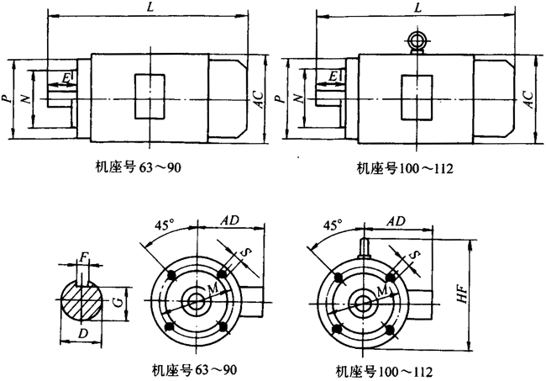
立式安装，机座不带底脚，端盖上有凸缘（带通孔），轴伸向下的电动机（IMV1）（单位：mm）
机座号 | 凸缘号 | 极数 | D | E | F | G | M | N | P | S | AC | AD | HF | L
180M | FF300 | 2、4、6、8 | 48 | 110 | 14 | 42.5 | 300 | 250 | 350 | 19 | 380 | 280 | 500 | 760
180L |  |  |  |  |  |  |  |  |  |  |  |  |  | 800
200L | FF350 | 2、4、6、8 | 55 | 110 | 16 | 49 | 350 | 300 | 400 | 19 | 420 | 305 | 550 | 840
225S | FF400 | 4、8 | 60 | 140 | 18 | 53 | 400 | 350 | 450 | 19 | 470 | 335 | 610 | 905
225M | FF400 | 2 | 55 | 110 | 16 | 49 |  |  |  |  |  |  |  | 910
225M | FF400 | 4、6、8 | 60 | 140 | 18 | 53 |  |  |  |  |  |  |  | 935
250M | FF500 | 2 |  |  |  |  | 500 | 450 | 550 | 19 | 510 | 370 | 650 | 1015
250M | FF500 | 4、6、8 | 65 | 140 | 18 | 58
280S | FF500 | 2 |  |  |  |  |  |  |  |  | 580 | 410 | 720 | 1110
280S | FF500 | 4、6、8 | 75 | 140 | 20 | 67.5
280M | FF500 | 2 | 65 | 140 | 18 | 58 |  |  |  |  |  |  |  | 1150
280M | FF500 | 4、6、8 | 75 | 140 | 20 | 67.5
315S | FF600 | 2 | 65 | 140 | 18 | 58 | 600 | 550 | 660 | 24 | 645 | 530 | 900 | 1280
315S | FF600 | 4、5、8、10 | 80 | 170 | 22 | 71 |  |  |  |  |  |  |  | 1510
315M | FF600 | 2 | 65 | 140 | 18 | 58 |  |  |  |  |  |  |  | 1310
315M | FF600 | 4、5、8、10 | 80 | 170 | 22 | 71 |  |  |  |  |  |  |  | 1430
315L | FF600 | 2 | 65 | 140 | 18 | 58 |  |  |  |  |  |  |  | 1310
315L | FF600 | 4、5、8、10 | 80 | 170 | 22 | 71 |  |  |  |  |  |  |  | 1430
355M | FF740 | 2 | 75 | 140 | 20 | 67.5 | 740 | 680 | 800 | 24 | 710 | 655 | 1010 | 1640
355M | FF740 | 4、5、8、10 | 95 | 170 | 25 | 86 |  |  |  |  |  |  |  | 1670
355L | FF740 | 2 | 75 | 140 | 20 | 67.5 |  |  |  |  |  |  |  | 1640
355L | FF740 | 4、5、8、10 | 95 | 170 | 25 | 86 |  |  |  |  |  |  |  | 1670

