DC/DC电源模块 1W, 小型
MAU100 / MAU200系列
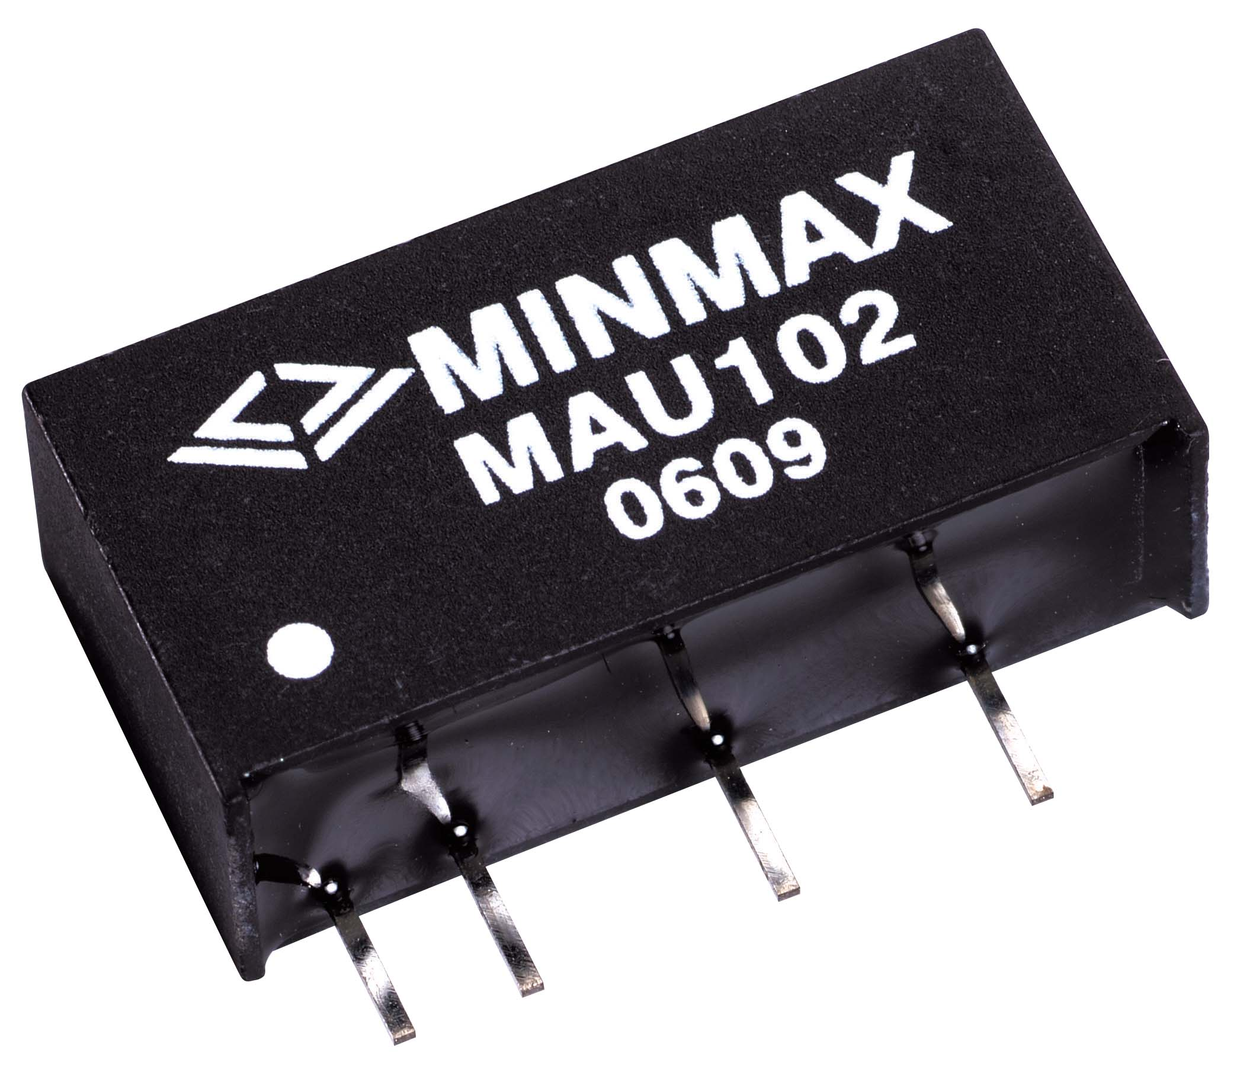 |  | 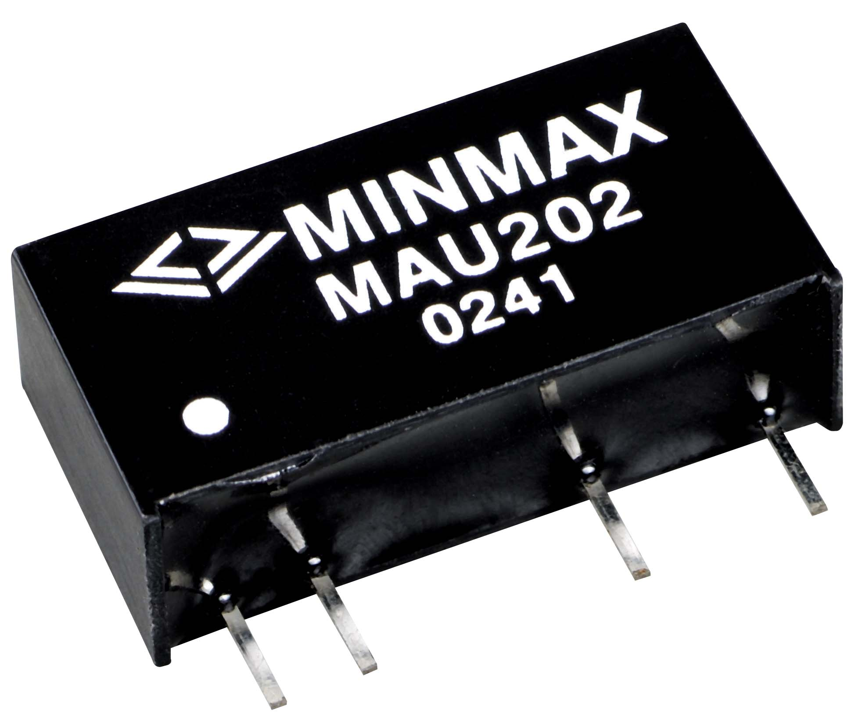 |  | 产品型号 |  | 输入电压 | 输出电压 | 输出电流
 |  |  |  | 耐压
 |  |  |  | 1kVDC | 3kVDC | VDC | VDC | mA Max.
 |  |  |  | MAU101 | MAU201 | 5 ( 4.5 – 5.5 ) | 3.3 | 260
 |  |  |  | MAU102 | MAU202 | 5 ( 4.5 – 5.5 ) | 5 | 200
 |  |  |  | MAU103 | MAU203 | 5 ( 4.5 – 5.5 ) | 9 | 110
 |  |  |  | MAU104 | MAU204 | 5 ( 4.5 – 5.5 ) | 12 | 84
 |  |  |  | MAU105 | MAU205 | 5 ( 4.5 – 5.5 ) | 15 | 67
 |  |  |  | MAU106 | MAU206 | 5 ( 4.5 – 5.5 ) | ±5 | ±100
 |  |  |  | MAU107 | MAU207 | 5 ( 4.5 – 5.5 ) | ±9 | ±56
产品特性 |  |  |  | MAU108 | MAU208 | 5 ( 4.5 – 5.5 ) | ±12 | ±42
产品特性 |  |  |  | MAU109 | MAU209 | 5 ( 4.5 – 5.5 ) | ±15 | ±34
 |  |  |  | MAU111 | MAU211 | 12 ( 10.8 – 13.2 ) | 3.3 | 260
• 输出电压准确度 | ±1.0%典型值 |  |  | MAU112 | MAU212 | 12 ( 10.8 – 13.2 ) | 5 | 200
• 电压调整率 | ±1.2%典型值 |  |  | MAU113 | MAU213 | 12 ( 10.8 – 13.2 ) | 9 | 110
• 负载调整率 | ±10% 最大值 |  |  | MAU114 | MAU214 | 12 ( 10.8 – 13.2 ) | 12 | 84
• 涟波杂讯 | 65mV P-P typ |  |  | MAU115 | MAU215 | 12 ( 10.8 – 13.2 ) | 15 | 67
• 短路保护模式 | 短暂 |  |  | MAU116 | MAU216 | 12 ( 10.8 – 13.2 ) | ±5 | ±100
• 隔离电压 | MAU100 – 1kVDC |  |  | MAU117 | MAU217 | 12 ( 10.8 – 13.2 ) | ±9 | ±56
 | MAU200 – 3kVDC |  |  | MAU118 | MAU218 | 12 ( 10.8 – 13.2 ) | ±12 | ±42
• 效率 | 81% |  |  | MAU119 | MAU219 | 12 ( 10.8 – 13.2 ) | ±15 | ±34
• 切换频率 | 100kHz 典型值 |  |  | MAU151 |  | 15 ( 13.5 – 16.5 ) | 5 | 200
• 工作温度 | -40°C to +85°C |  |  | MAU152 |  | 15 ( 13.5 – 16.5 ) | 12 | 84
• 外壳材质 | 塑胶, 94V-0 |  |  | MAU153 |  | 15 ( 13.5 – 16.5 ) | 15 | 67
• 平均故障使用时间 | 2 MHours min |  |  | MAU154 |  | 15 ( 13.5 – 16.5 ) | ±5 | ±100
 |  |  |  | MAU155 |  | 15 ( 13.5 – 16.5 ) | ±12 | ±42
 |  |  |  | MAU156 |  | 15 ( 13.5 – 16.5 ) | ±15 | ±34
 |  |  |  | MAU121 | MAU221 | 24 ( 21.6 – 26.4 ) | 3.3 | 260
 |  |  |  | MAU122 | MAU222 | 24 ( 21.6 – 26.4 ) | 5 | 200
 |  |  |  | MAU123 | MAU223 | 24 ( 21.6 – 26.4 ) | 9 | 110
 |  |  |  | MAU124 | MAU224 | 24 ( 21.6 – 26.4 ) | 12 | 84
 |  |  |  | MAU125 | MAU225 | 24 ( 21.6 – 26.4 ) | 15 | 67
 |  |  |  | MAU126 | MAU226 | 24 ( 21.6 – 26.4 ) | ±5 | ±100
 |  |  |  | MAU127 | MAU227 | 24 ( 21.6 – 26.4 ) | ±9 | ±56
 |  |  |  | MAU128 | MAU228 | 24 ( 21.6 – 26.4 ) | ±12 | ±42
 |  |  |  | MAU129 | MAU229 | 24 ( 21.6 – 26.4 ) | ±15 | ±34

MAU100系列 |  |  |  | MAU200系列 |  |  | MAU100
 |  |  |  |  |  | Pin | Single | Dual
 |  |  |  |  |  | 1 | +Vin | +Vin
 |  |  |  |  |  | 2 | -Vin | -Vin
 |  |  |  |  |  | 4 | -Vout | -Vout
 |  |  |  |  |  | 5 | No Pin | Common
 |  |  |  |  |  | 6 | +Vout | +Vout
 |  |  |  |  |  |  | MAU200
 |  |  |  |  |  | Pin | Single | Dual
 |  |  |  |  |  | 1 | +Vin | +Vin
 |  |  |  |  |  | 2 | -Vin | -Vin
 |  |  |  |  |  | 5 | -Vout | -Vout
 |  |  |  |  |  | 6 | No Pin | Common
 |  |  |  |  |  | 7 | +Vout | +Vout
 |  |  |  |  |  | T = 6.1 [0.24] for 5V & 12V input models
 |  |  |  |  |  | T = 7.1 [0.28] for 15V & 24V input models

6 Download full datasheet at www.mldz.com.cn

